**To:** Jie Yang  
**From:** Team 5, EE-286 Section 1Mason Gerace, Felecia Hildebran, Joshua Pollock, Taylor Yee  
**Date:**  November 29, 2018 **RE:** Project 3 - Demo Update Memo

**Assignment:**

The team will submit a memo detailing progress up to the demo. This will include a Gantt chart updated to reflect any changes in the scheduling along with task accountability information. The original Gantt chart will be presented along the revised chart with detailed annotations of the changes. Don’t forget to include the updated WBS. Also include any schematics and bill of materials for your project. This will be due November 29 at 11:59 pm. No submission will be accepted after November 30 at 11:59 pm.

**Introduction:**

The team is submitting a demo update memo to the TAs and Professor Yang. Revised versions of the team’s Gantt and WBS charts will be presented with remarks on the changes made to each item. Additionally, schematics and a full bill of materials for the project will be provided. Finally, the memo will give an overall update on the status of the project and progress towards completion.

**Updates to Gantt Chart**:

* Programming and Building - Motors timeline was changed to end by December 4th instead of November 28th.
* Programming and Building - Buzzer, LED, button timeline was changed to end by December 2nd instead of November 28th.
* Mount Wheels and Motors timeline was changed to end by November 25th instead of November 20th.
* Ensure Wheels Work Properly timeline was changed to end by December 4th instead of November 23rd.
* Changed Project Report timeline to end by December 4th instead of December 3rd.
* Changed Project Report Due milestone December 4th instead of December 3rd.

**Gantt:**

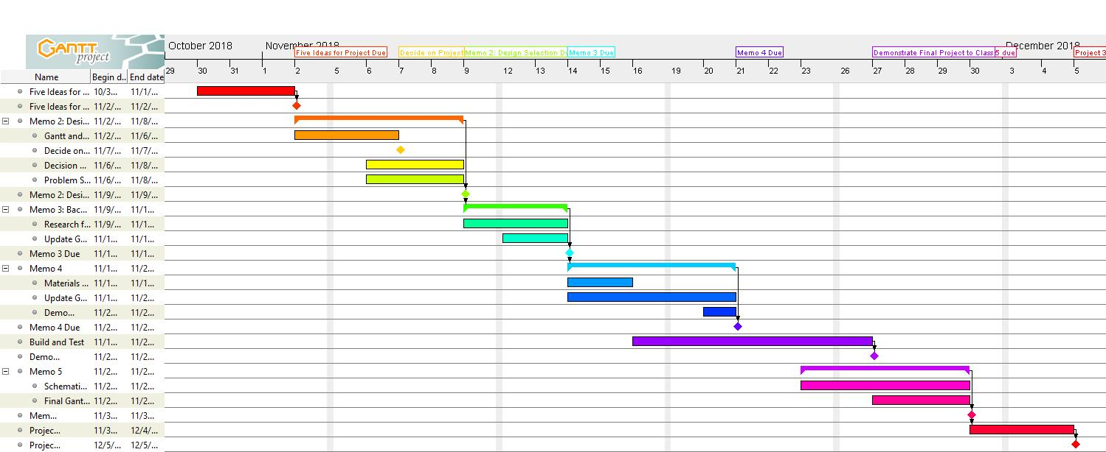

**Figure 1: Original Gantt Chart**

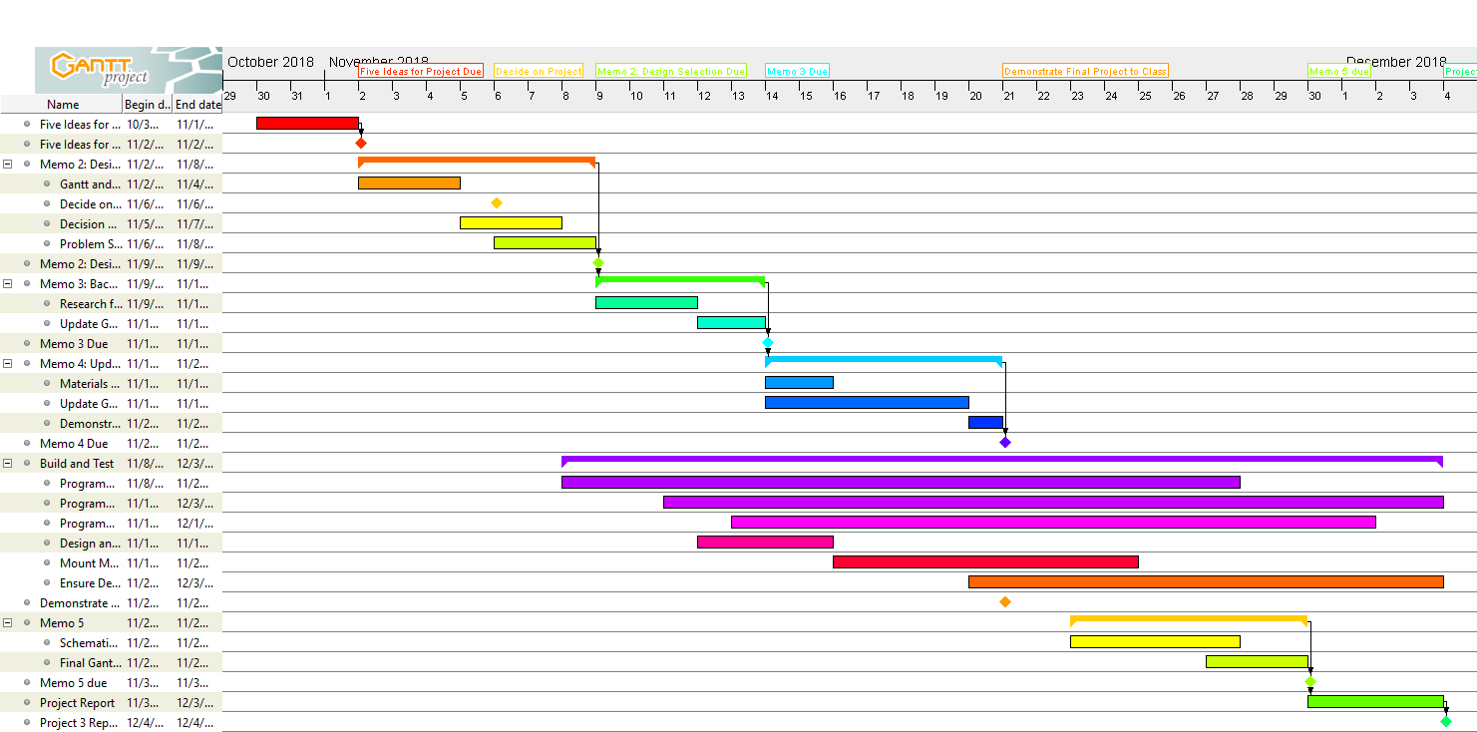

**Figure 2: Updated Gantt Chart**

**Updates to WBS:**

* Updated what was completed
* Updated in-progress assignments

**WBS:**

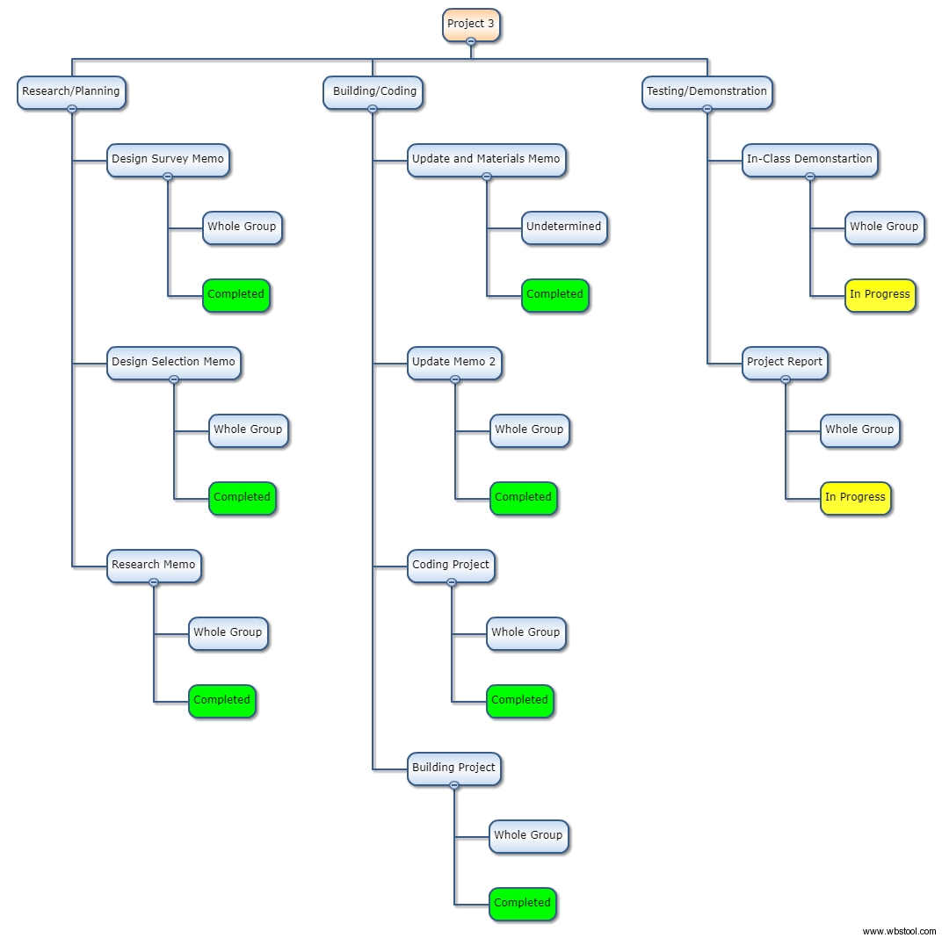

**Figure 3: Updated WBS Chart**

**Schematic:**

Below is a rough schematic for our autonomous rover. The only pieces missing from the image are the 3D printed wheels that we designed in the MakerLab. Our three sensors (buttons, ultrasonic sensor, and piezo buzzer) can be see along the edges of the design and on the Arduino Uno as well.

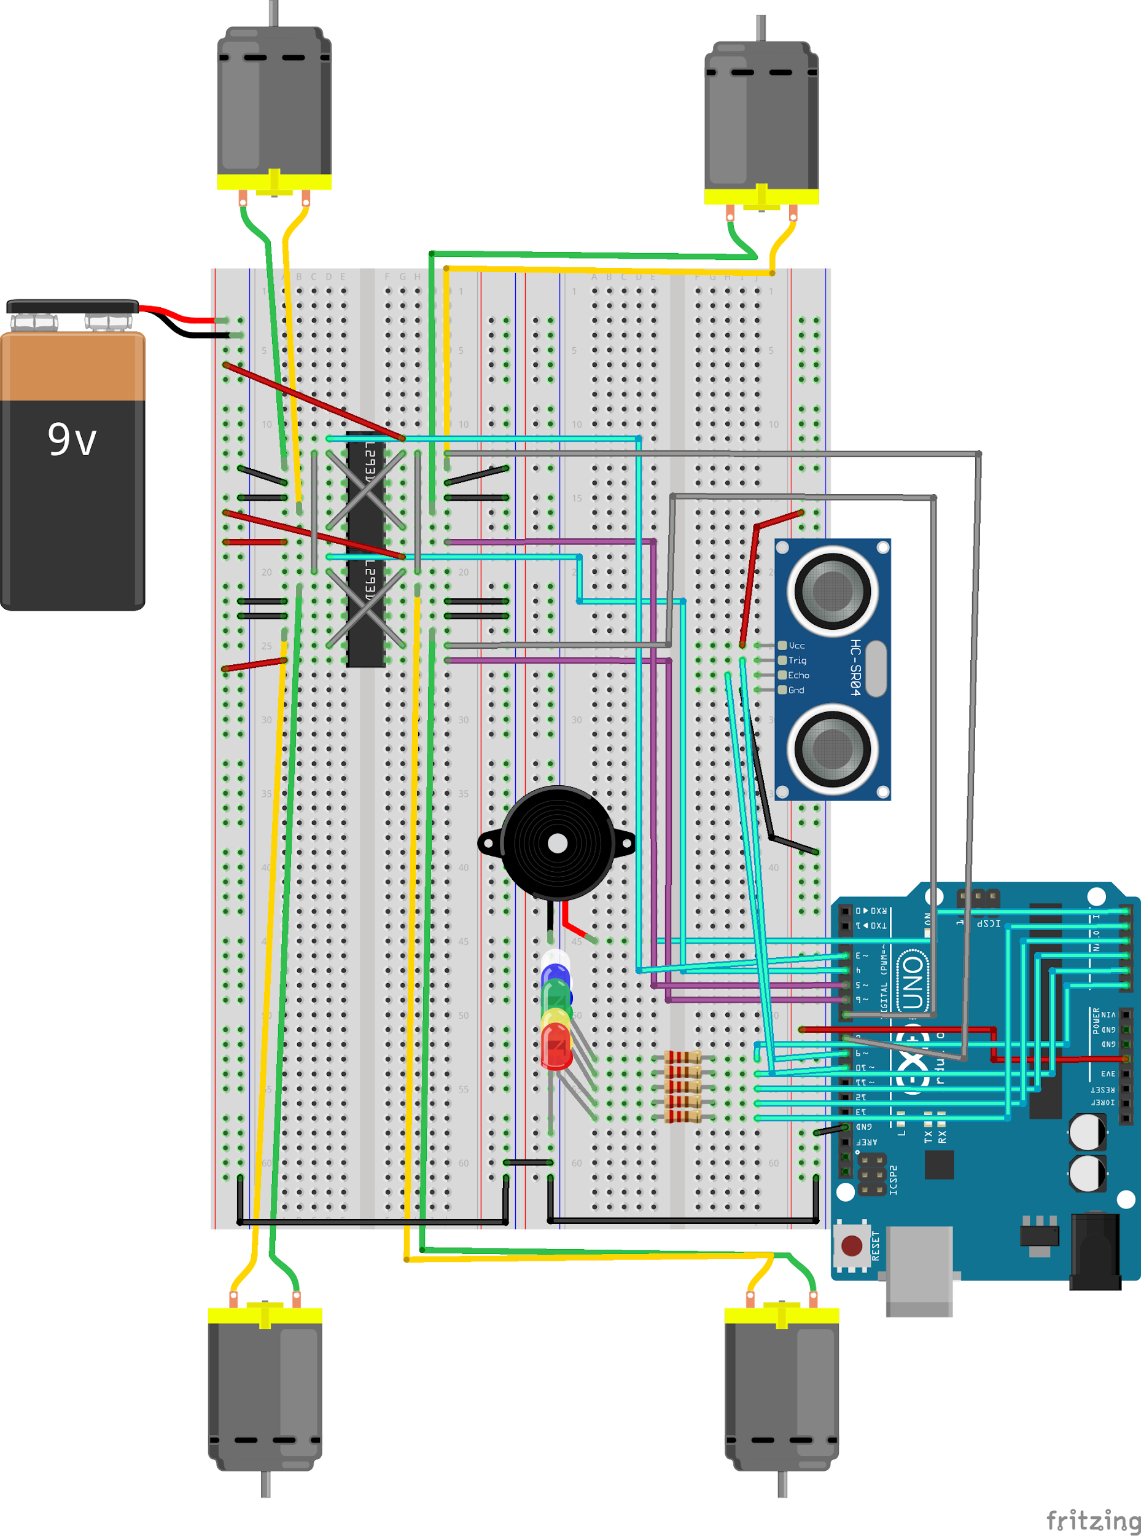

**Figure 4: Breadboard schematic**

**Bill of Materials (in addition to Arduino Uno, expansion board, and breadboard):**

* 5 LEDs (White, Blue, Green, Yellow, Red; 1 ea.)
* 4 wheels (3D printed)
* 4 brushed DC motors
* 5 220Ω resistors
* 2 9V batteries
* 6 AA batteries
* 2 9V battery clips
* 1 active buzzer
* 2 L293D motor drivers
* 1 HC-SR04 ultrasonic sensor
* Jumper wires (Female->Male and Male->Male)

**Conclusion:**

In this memo, an update for progress leading up to the demo was presented. We included revised Gantt and WBS charts, a schematic, bill of materials, and an overall progress update. Our team was not ready to present on Thursday, but we are confident that our design will be ready to be demonstrated by next Tuesday. Our only problem at this point in time is getting our rover’s wheels to rotate when placed on a surface, since they rotate perfectly well while in the air.

**Attachments:** none